# **Starting Guide to Yarn**

Starting Guide to Yarn

Yarn Basics

When to Change Nodes

Variables, Commands and Game Team Instructions within Yarn:

Else / If Statements

Saving

Writing Yarn in a Plain txt Doc:

Extra Example:

Validating your Yarn

Using Yarn in Unity

Variables in Yarnspinner

All the Links

## Yarn Basics

<https://github.com/InfiniteAmmoInc/Yarn> 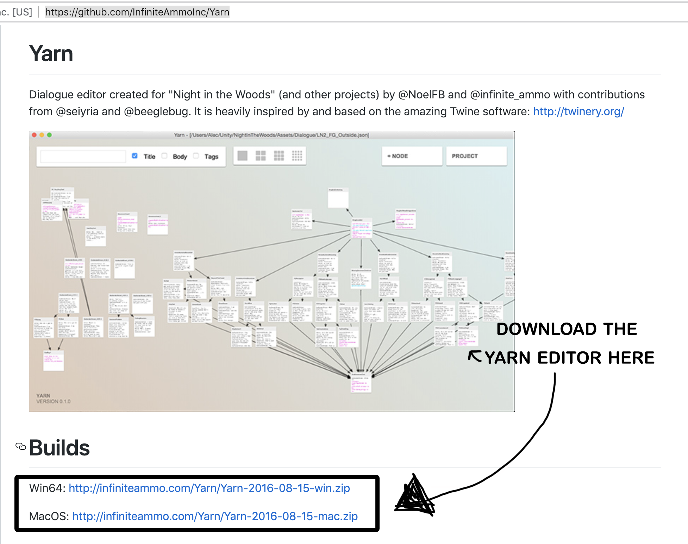

The **yarn editor** is the IDE [integrated development environment] for yarn. It is a visual way to write nodes and to see how each node connects to each other. However, **you do not need to use the editor to write the script**. It is just a convenient way to view connections and titles If the text-based method is confusing. Yarn also now has a web-based editor too!

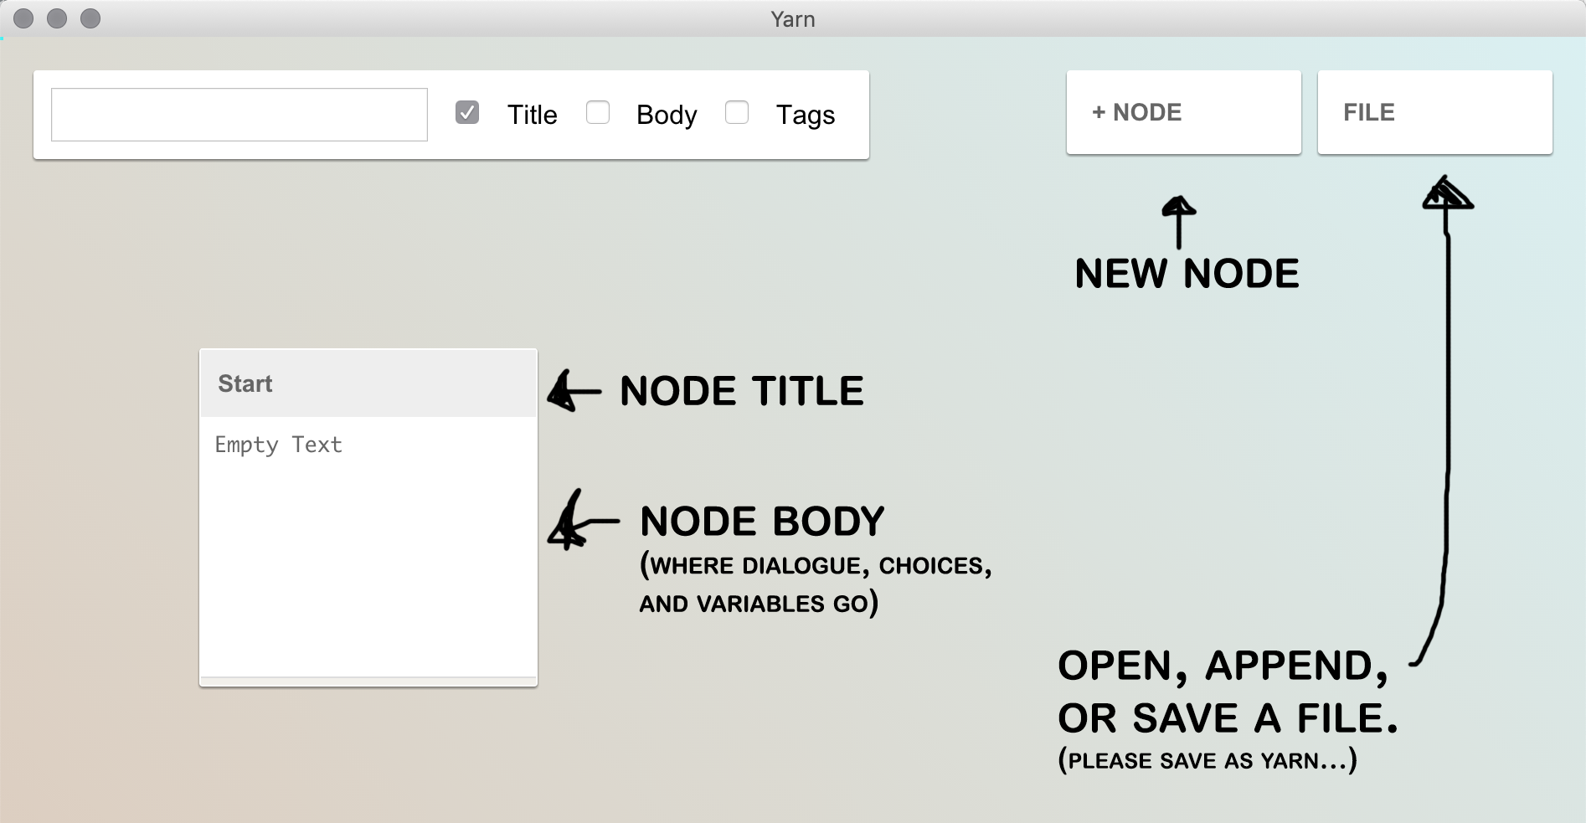

A screenshot of the Yarn editor with labels

*file can be saved as .yarn or .json, but I think .json is more work to import

This is the basic structure of the editor. Important notes:

* **A node can have multiple characters speaking in the Body**

Character1: Hey.

Character2: Oh! Hi.

Character2: You snuck up on me.

* Each line that you write is displayed on a new line (ie, the first line plays, then the player clicks, then the second line replaces it)
* **Changing a node looks like this:**

[[Words to describe choice|nameOfNewNode]]

* The words before | represent the dialogue that appears as the choice, like “That sounds like a good idea!” “Go Left” or “Pick up the can of tuna”
* The thing after the | is the node you want the choice to lead to.
* You cannot have a space before or after |nameOfNewNode
  + The visual editor will color this, but you can always check by running your code
* To visit a node without a player choice, omit any text and the |:

[[nameOfNewNode]]

* **Node Titles**
* Each node should have a unique title to avoid confusion
* If you are using a character’s name, use “Name.Start” or “Name.Anger” instead of “Name” for clarity
* Node names cannot contain spaces
* **Comments**

Use two slashes “//” for games team instructions

## When to Change Nodes

* when the player makes an important choice
* a conversation ends.
* When the player talks to different characters
* You want multiple choices to lead to a certain point

## Variables, Commands and Game Team Instructions within Yarn:

<https://github.com/thesecretlab/YarnSpinner/blob/master/Documentation/YarnSpinner-Dialogue/General-Usage.md>

* All variables need to be prefixed by $
* These variables end up stored in ExampleVariableStorage
* Unity can read Yarn variables, but changing them in unity does not change them in yarn.

## Else / If Statements

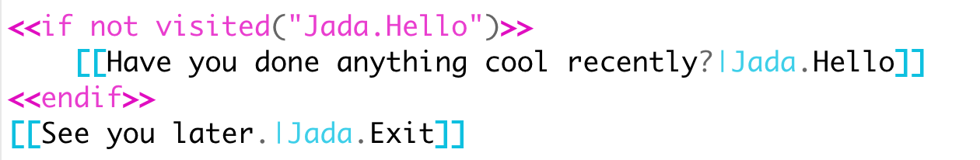

An example of an if statement

* In this example, Yarn is checking if the function visited (which checks to see if a node (Jada.Hello) has already been seen by the player) is true.
* You need to use the <<>> format
* <<endif>> is like your {} - you need it for the if statement to work correctly

## Saving

* Keep the .yarn.txt or .json
* Avoid using spaces - party_start, partyStart, or party-start instead of “party start”

## Writing Yarn in a Plain txt Doc:

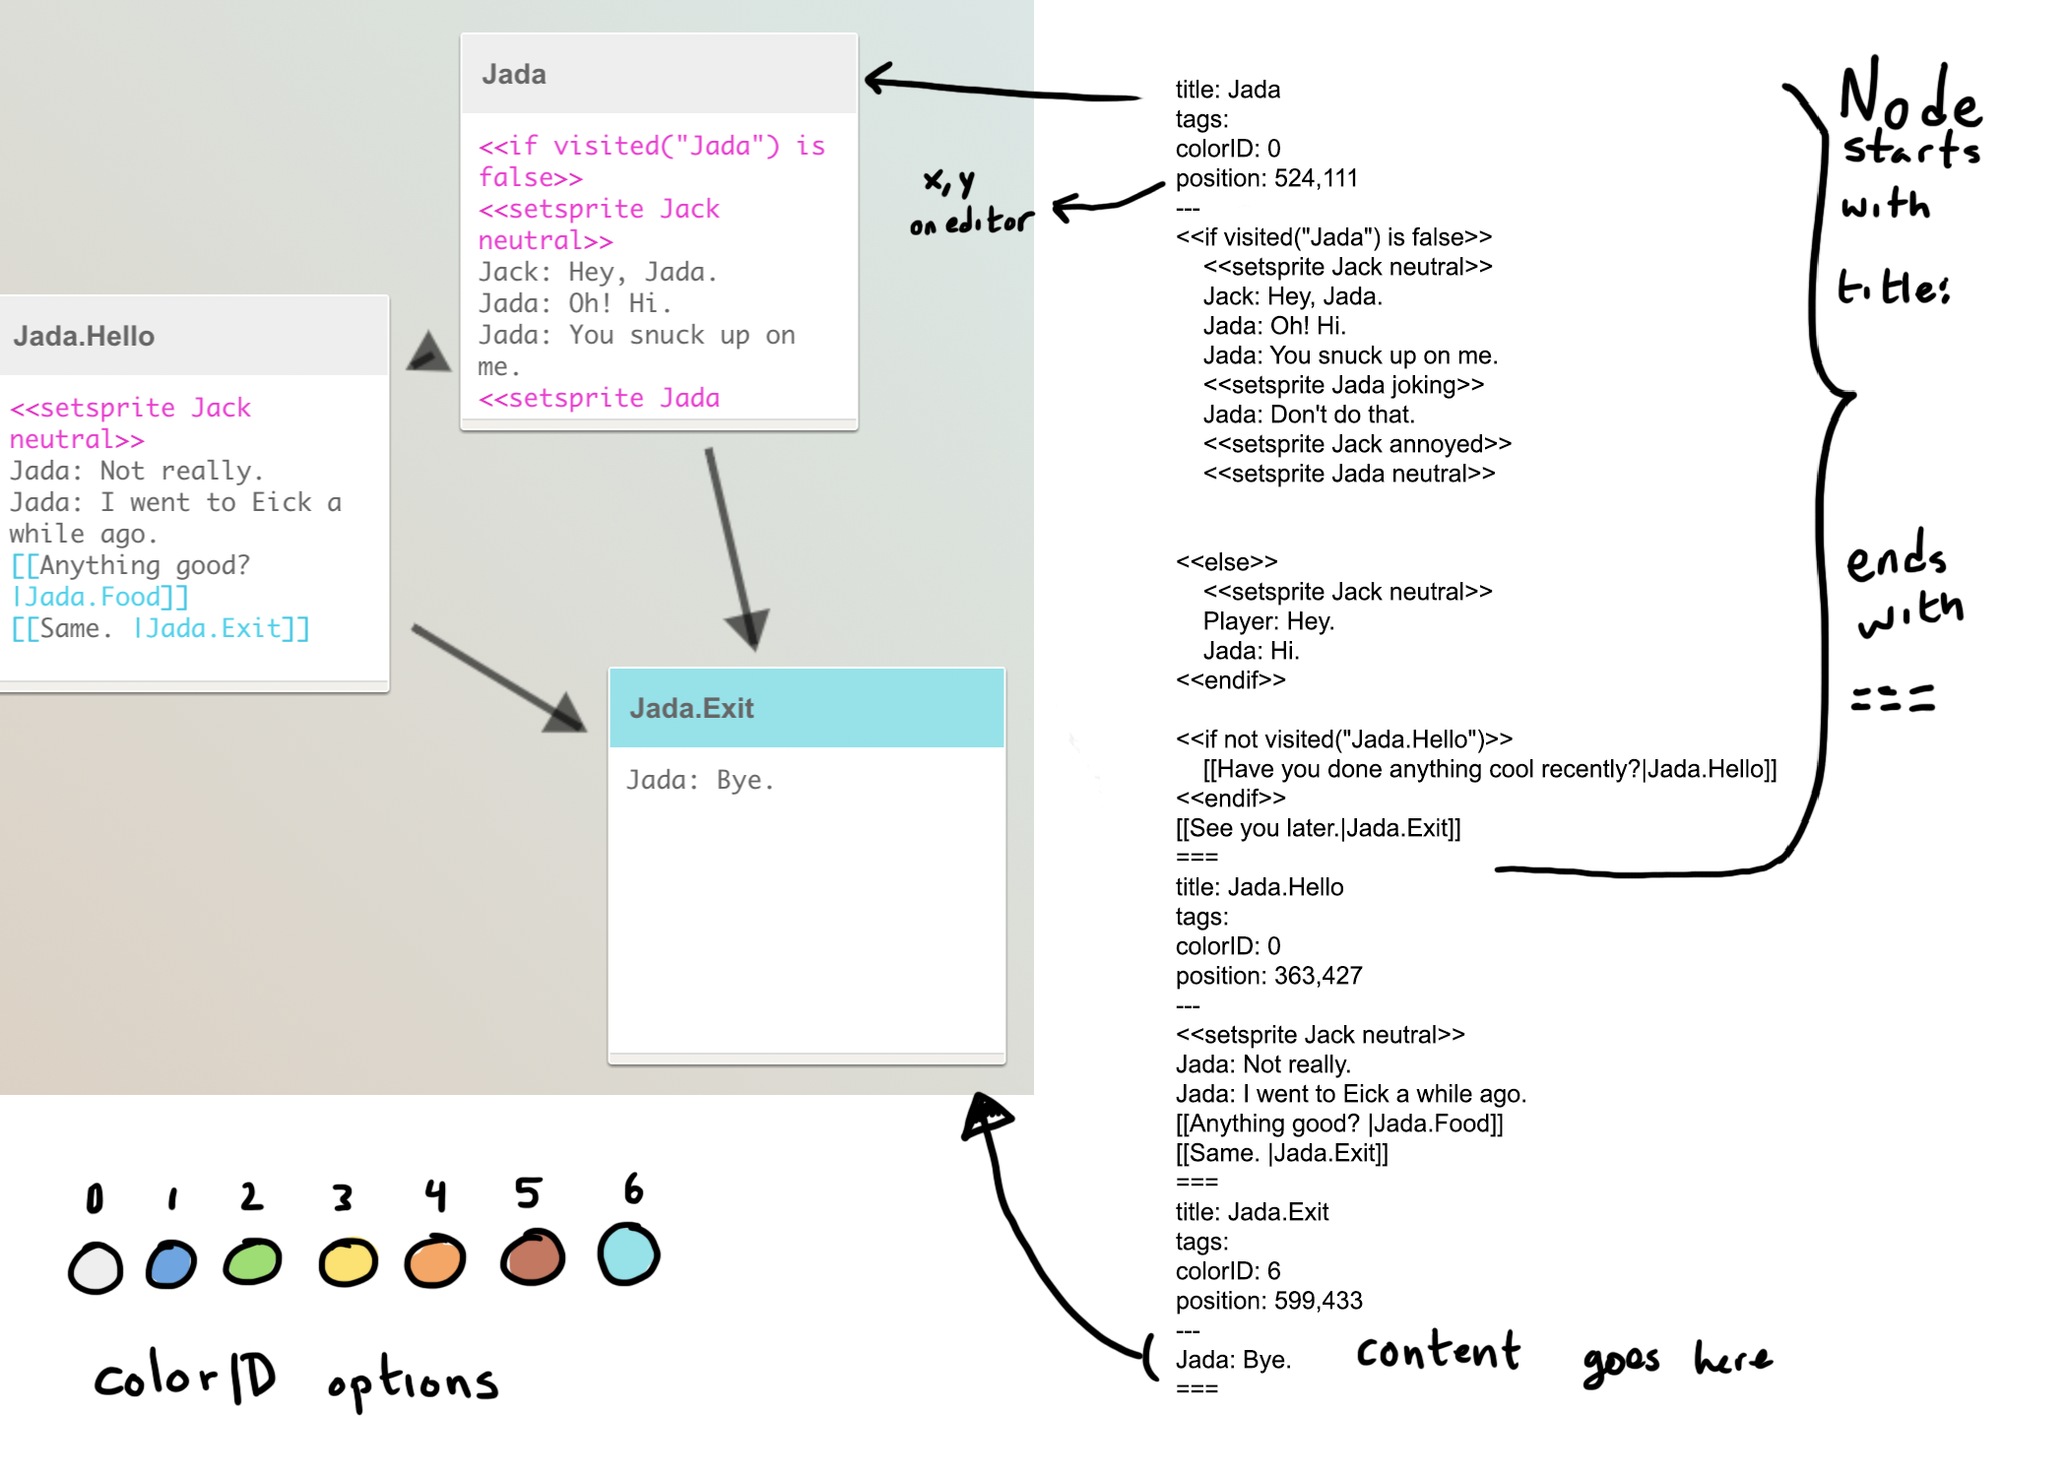

An example of the written Yarn script compared to how it appears in the editor

title: Node

tags:

colorID: 0

position: X,Y

---

Name1: Hey, Jada.

Name2: Oh! Hi.

Name3: How are you?

===

Yarn Commands

To use a Yarn Command open and close with “<<” and “>>”

## Extra Example:

<https://docs.google.com/document/d/1vqrvPEKtyjJ8r6td-7ZoX0uuViRYDJyZSpG3yrBqu7s/edit?usp=sharing>

title: Start

tags:

colorID: 0

position: 755,-3

---

A: I am a character.

B: So am I.

->this is a player option that doesn’t change nodes

A: This is dialogue again!

[[ this is your first node choice |choice1]]

[[this is your second! |choice2]]

===

title: choice1

tags:

colorID: 0

position: 562,246

---

word

===

title: choice2

tags:

colorID: 0

position: 935,249

---

Empty Text

===

## Validating your Yarn

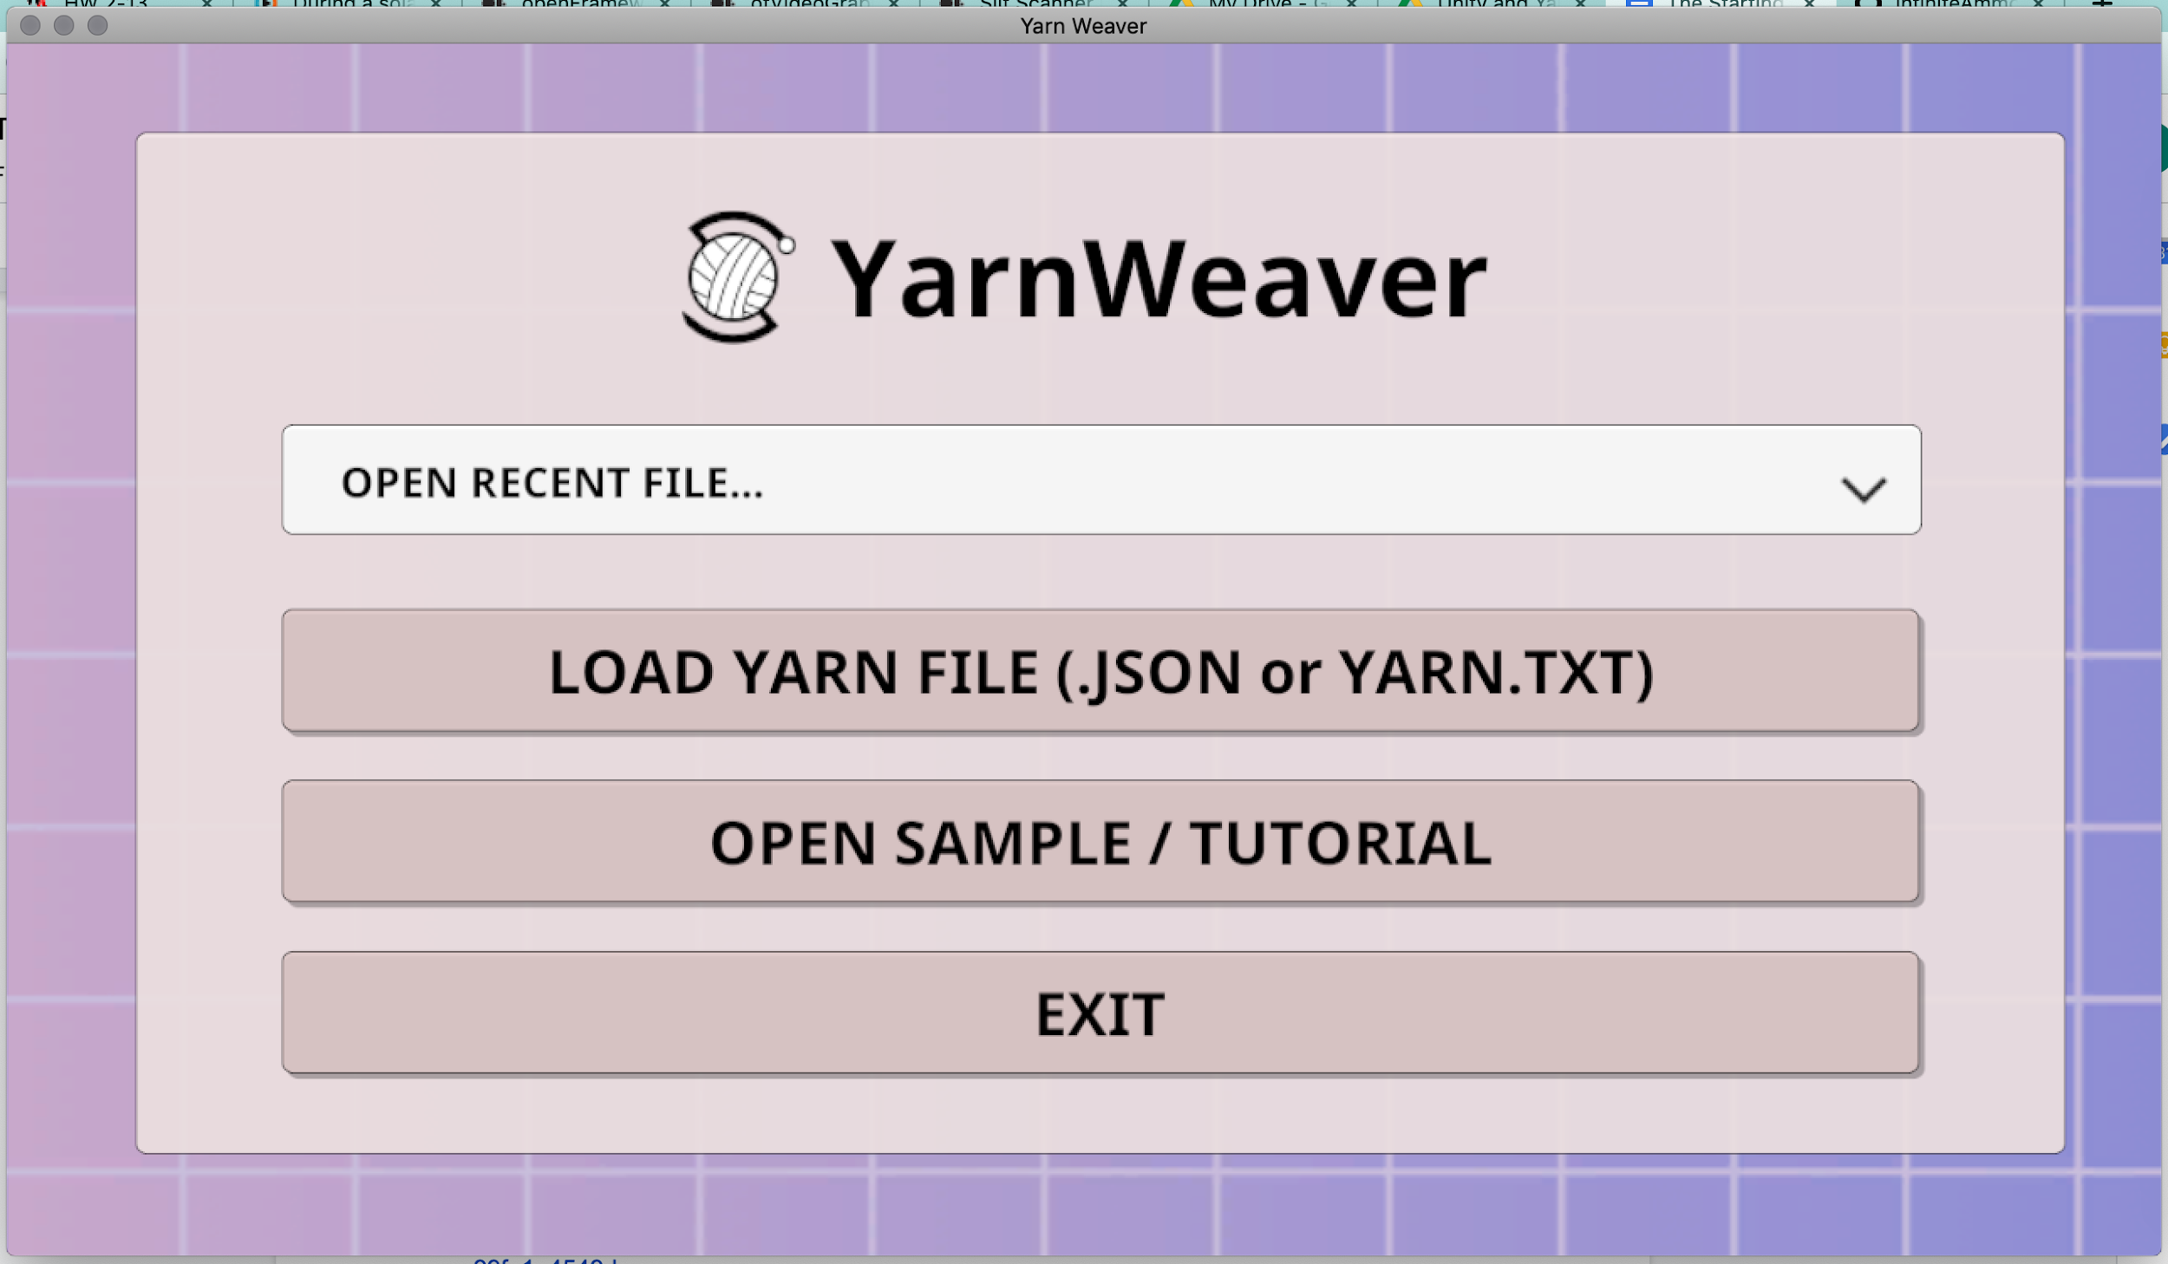

<https://www.blog.radiator.debacle.us/2017/09/writing-stories-dialogue-for-unity.html>

<https://github.com/radiatoryang/Yarn-Weaver/releases>

Yarn Weaver is a tool made to test Yarn Dialogue. Opening a file runs it as dialogue, and it lets you know if something is going wrong!

This is also done in Merino! It was made by the same person.

# **Using Yarn in Unity**

<https://docs.google.com/presentation/d/1o22Uoshvt5EKkrquSf70RAgJqF0OyhblEhG4GSxQmH4/edit?usp=sharing>

### Variables in Yarnspinner

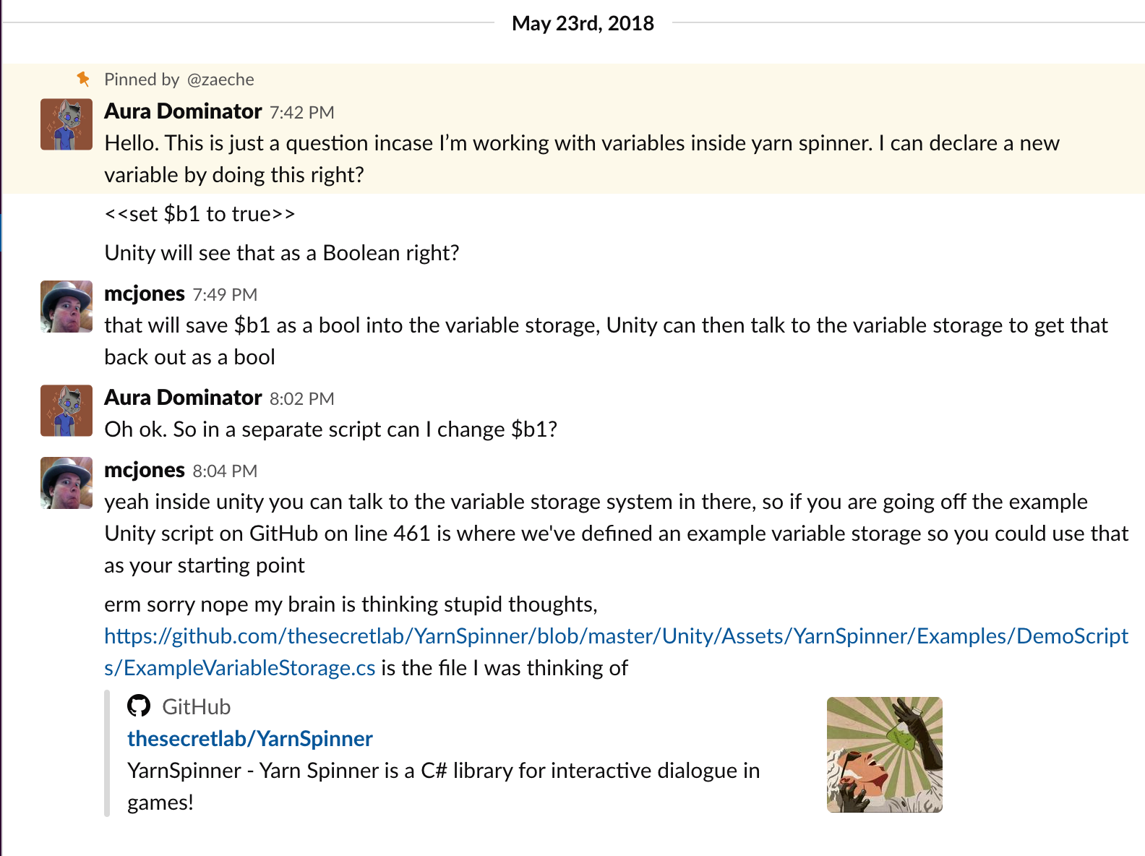

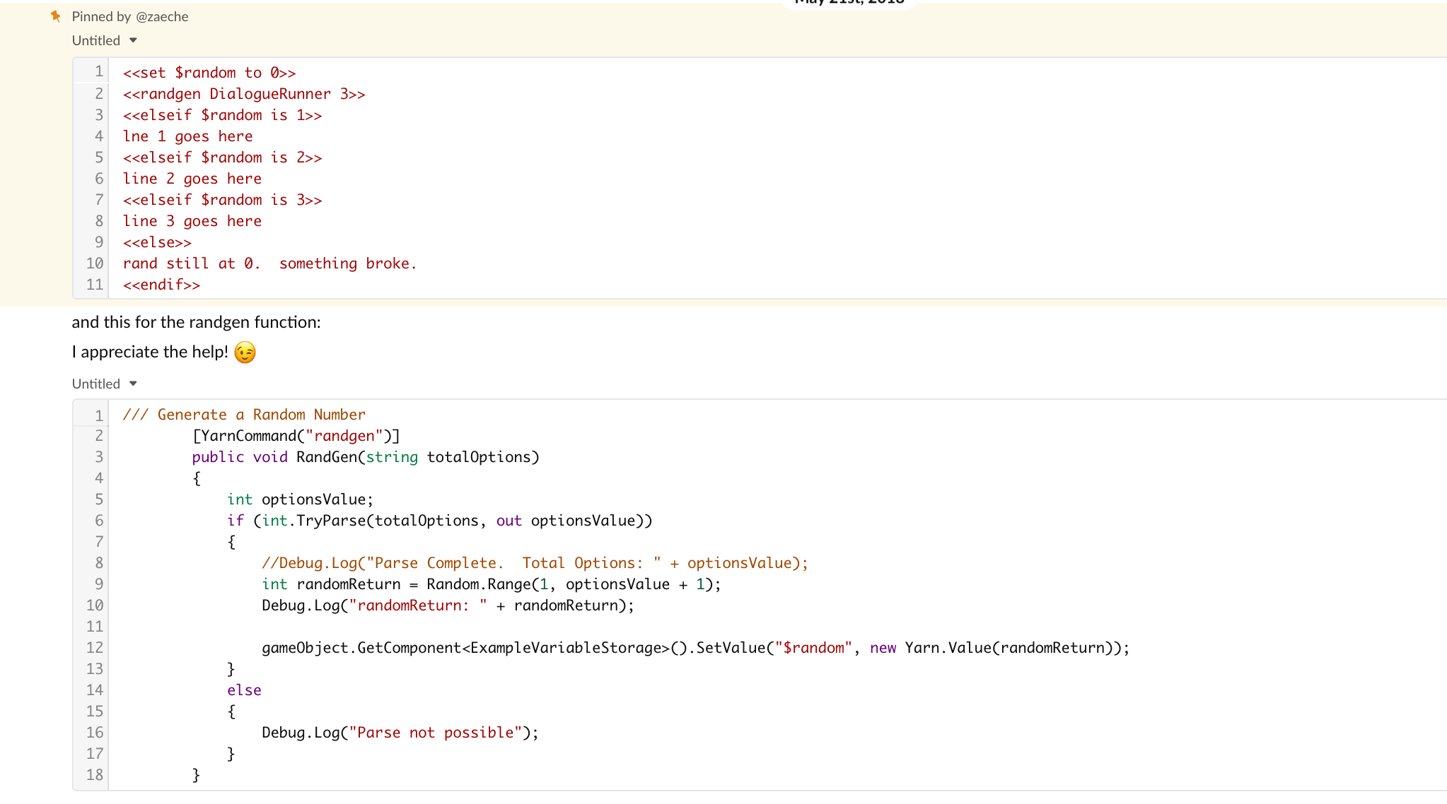

### All the Links

<https://github.com/YarnSpinnerTool/YarnEditor>

The yarn spinner editor!

<https://github.com/YarnSpinnerTool/YarnSpinner/blob/master/Documentation/YarnSpinner-Dialogue/Yarn-Syntax.md>

Yarn’s Guide to Writing in the yarn editor! Includes online stuff!

<https://github.com/YarnSpinnerTool/YarnSpinner/blob/master/Documentation/YarnSpinner-Dialogue/README.md>

Yarnspinner’s guide to writing Yarn Dialogue

<https://github.com/YarnSpinnerTool/YarnSpinner/blob/master/Documentation/YarnSpinner-Unity/YarnSpinner-with-Unity-StepByStep.md>

Yarnspinner’s primer for using Yarn + Yarnspinner!

<https://github.com/YarnSpinnerTool/YarnSpinner/blob/master/Documentation/YarnSpinner-Dialogue/Complex-Dialogue-Tutorial.md>

This is Yarnspinner’s tutorial on how to build their complex tutorial!

<https://www.secretlab.com.au/blog/2017/11/14/how-night-in-the-woods-uses-yarn-spinner>

How A Night in The Woods uses Yarnspinner